CHAPTER 3

Demand, Supply, and Market Equilibrium

Chapter 3 introduces the most fundamental tools of economic analysis: demand and supply. Demand and supply are simply “boxes” or categories into which all the forces and factors that affect the price and the quantity of a good bought and sold in a competitive market are placed. Demand and supply determine price and quantity exchanged. It is necessary to understand why and how they do this.

Many students never learn to define demand and supply. They never learn (1) what an increase or decrease in demand or supply means, (2) the important distinctions between “demand” and “quantity demanded” and between “supply” and “quantity supplied,” and (3) the equally important distinctions between a change in demand and a change in quantity demanded, and between a change in supply and a change in quantity supplied.

Having learned these, however, it is no great trick to comprehend the so-called laws of demand and supply. The equilibrium price— that is, the price that will tend to prevail in the market as long as demand and supply do not change— is simply the price at which quantity demanded and quantity supplied are equal. The equilibrium quantity is the quantity demanded and supplied at the equilibrium price.

This chapter includes a brief examination of the factors that determine demand and supply and the ways in which changes in these determinants will affect and cause changes in demand and supply. A graphic method is used in this analysis to illustrate demand and supply, equilibrium price and quantity, changes in demand and supply, and the resulting changes in equilibrium price and quantity. The demand curve and the supply curve are graphic (or geometric) representations of the same data contained in the schedules of demand and supply.

The application section at the end of the chapter explains government-set prices. When the government sets a legal price in a competitive market, it creates a price ceiling or price floor. This prevents supply and demand from determining the equilibrium price and quantity of a product that will be provided by a competitive market. The economic consequence of a price ceiling is that it will result in a persistent shortage of the product. An example of a price ceiling would be price controls on apartment rents. A price floor will result in a persistent surplus of a product, and the example given for it is price supports for an agricultural product.

Demand and supply are used over and over in this book. It is as important in economics as jet propulsion is to the pilot of a jet airplane: You can’t get off the ground without it.

- CHECKLIST

When you have studied this chapter you should be able to

- Define a market.
- Define demand and state the law of demand.
- Graph the demand curve when you are given a demand schedule.
- Explain the difference between individual demand and market demand.
- List the major determinants of demand and explain how each one shifts the demand curve.
- Distinguish between change in demand and change in the quantity demanded.
- Define supply and state the law of supply.
- Graph the supply curve when you are given a supply schedule.
- List the major determinants of supply and explain how each shifts the supply curve.
- Distinguish between change in supply and change in the quantity supplied.
- Describe how the equilibrium price and quantity are determined in a competitive market.
- Explain the rationing function of prices.
- Define surplus and shortage.
- Apply economic analysis to ticket scalping.
- Predict the effects of changes in demand on equilibrium price and equilibrium quantity holding supply constant.
- Predict the effect of changes in supply on equilibrium price and equilibrium quantity holding demand constant.
- Predict the effect of simultaneous changes in demand and supply on equilibrium price and equilibrium quantity.
- Explain the economic effects of a government-set price ceiling on product price and quantity in a competitive market and apply it to the market for gasoline.
- Describe the economic consequences of a government-set price floor on product price and quantity in a competitive market and apply it to the market for rental housing.
- CHAPTER OUTLINE

- A market is any institution or mechanism that brings together buyers (“demanders”) and sellers (“suppliers”) of a particular good or service. This chapter assumes that markets are competitive.

- Demand is a schedule of prices and the quantities that buyers would purchase at each of these prices during a selected period of time.
  - As price rises, other things being equal, buyers will purchase smaller quantities, and as price falls they will purchase larger quantities; this is the law of demand.
  - The demand curve is a graphic representation of demand and the law of demand.
  - Market (or total) demand for a good is a summation of the demands of all individuals in the market for that good.
  - The demand for a good depends on consumers’ tastes, the number of consumers in the market, consumers’ incomes, the prices of related goods, and expected prices.
  - A change (increase or decrease) in the entire demand schedule and the demand curve is referred to as a change in demand. It is the result of a change in one or more of the determinants of demand. For example, an increase in the demand for a good may result from an increase in:
    - tastes or preferences for the good;
    - the number of buyers for the good;
    - income if it is a normal good, but with an inferior good it would result from a decrease in income;
    - the price of a related good, but if they are complements, it may result from a decrease in the price of a related good; and
    - changes in expected prices for the good.
  - A change in demand and a change in the quantity demanded are not the same thing.

- Supply is a schedule of prices and the quantities that sellers will sell at each of these prices during some period of time.
  - The supply schedule shows, other things equal, that as the price of the good rises larger quantities will be offered for sale, and that as the price of the good falls, smaller quantities will be offered for sale.
  - The supply curve is a graphic representation of supply and the law of supply; the market supply of a good is the sum of the supplies of all sellers of the good.
  - The supply of a good depends on the prices of the resources employed in its production, the techniques used to produce it, the extent to which it is taxed or subsidized, the prices of other goods that might be produced, the price expectations of sellers, and the number of sellers of the product.
  - A change (increase or decrease) in the entire supply schedule and the supply curve is referred to as a change in supply. It is the result of a change in one or more of the determinants of supply. For example, an increase in supply for a good may result from:
    - a decrease in the prices of resources used to make it;
    - an improvement in the technology to produce it;
    - a fall in taxes on it, or an increase in subsidies for it;
    - a decline in the prices of other goods that could be produced by firms making it;
    - an increase or decrease (depending on the market in question) in expectations of its higher future price; and
    - an increase in the number of sellers of it.
  - A change in supply must be distinguished from a change in quantity supplied.

- The market or equilibrium price of a product is that price at which quantity demanded and quantity supplied are equal; the quantity exchanged in the market (the equilibrium quantity) is equal to the quantity demanded and supplied at the equilibrium price.
  - If the price of a product is above the market equilibrium price, there will be a surplus or excess supply. In this case, the quantity demanded is less than the quantity supplied at that price.
  - If the price of a product is below the market equilibrium price, there will be a shortage or excess demand. In this case, the quantity demanded is greater than the quantity supplied at that price.
  - The rationing function of prices is the elimination of surpluses and shortages of a product.

- A change in demand, supply, or both, changes both the equilibrium price and the equilibrium quantity in specific ways.
  - If demand increases (and supply stays the same), then equilibrium price and equilibrium quantity will increase. If demand decreases, then equilibrium price and equilibrium quantity will decrease.
  - If supply increases (and demand stays the same), then equilibrium price will decrease and equilibrium quantity will increase. If supply decreases, then equilibrium price will increase and equilibrium quantity will decrease.
  - If demand and supply both changes, then the effect on equilibrium price and equilibrium quantity will depend on the combination and size of the shifts. For example, if demand decreases and supply increases, the equilibrium price will decrease, but the equilibrium quantity may increase or decrease depending on the size of the shifts. (See #5 in Hints and Tips for all cases.)

- Supply and demand analysis has many important applications to government-set prices.
  - A price ceiling set by government prevents price from performing its rationing function in a market. It creates a shortage (quantity demanded is greater than the quantity supplied) at the government-set price. Another rationing method must be found, so government often steps in and establishes one. But all rationing systems have problems because they exclude someone. Also, a government-set price creates an illegal market for those who want to buy and sell above the government-set price.
    - Applying the Analysis (Price Ceilings on Gasoline). In this example a shortage is created because the government-set price is below the equilibrium so an illegal black market in gasoline is created.
    - Applying the Analysis (Rent Controls). Another example of a legal price ceiling that creates a shortage would be rent control established in some cities to restrain apartment rents.

  - A price floor is a minimum price set by government for the sale of a product or resource. It creates a surplus (quantity supplied is greater than the quantity demanded) at the fixed price. The surplus may induce the government to increase demand or decrease supply to eliminate the surplus.
    - Applying the Analysis (Price Floors on Wheat). The use of price floors has often been applied to several agricultural products such as wheat. The government-set price is above the equilibrium price and it creates a surplus of wheat.

- HINTS AND TIPS

- This chapter is the most important one in the book. Make sure you spend extra time on it and master the material. If you do, your long-term payoff will be a much easier understanding of the applications in later chapters.

- One mistake students often make is to confuse change in demand with change in quantity demanded. A change in demand causes the entire demand curve to shift, whereas a change in quantity demanded is simply a movement along an existing demand curve.
- Make a chart and related graphs that show the eight possible outcomes from changes in demand and supply. Figure 3.7 in the text illustrates the four single shift outcomes.

(1) D ↑: P ↑, Q ↑ | (3) S ↑: P ↓, Q ↑
(2) D ↓: P ↓, Q ↓ | (4) S ↓: P ↑, Q ↓

- Four shift combinations are described on p. 55 of the textbook.

(1) S ↑, D ↓: P ↓, Q ? | (3) S ↑, D ↑: P ?, Q ↑
(2) S ↓, D ↑: P ↑, Q ? | (4) S ↓, D ↓: P ?, Q ↓

- Practice always helps in understanding graphs. Without looking at the textbook, draw a supply and demand graph with a price ceiling below the equilibrium price and show the resulting shortage in the market for a product. Then, draw a supply and demand graph with a price floor above the equilibrium price and show the resulting surplus. Explain to yourself what the graphs show. Check your graphs and your explanations by referring to textbook Figures 3.8 and 3.9 and the explanations.

- IMPORTANT TERMS

demand  law of demand  demand curve  determinants of  demand  normal good  inferior good  substitute good  complementary good  change in demand  change in quantity demanded  supply | law of supply  supply curve  determinants of  supply  change in supply  change in quantity supplied  equilibrium price  equilibrium quantity  surplus  shortage  price ceiling  price floor

SELF-TEST

- FILL-IN QUESTIONS

- A market is the institution or mechanism that brings together buyers or (demanders, suppliers) _____________ and sellers or _______________ of a particular good or service.
- The relationship between price and quantity in the demand schedule is (a direct, an inverse) _______________ relationship; in the supply schedule the relationship is _______________ one.
- When demand or supply is graphed, price is placed on the (horizontal, vertical) ______________ axis and quantity on the ______________ axis.
- The change from an individual to a market demand schedule involves (adding, multiplying) _______________ the quantities demanded by each consumer at the various possible (incomes, prices) _______________.
- When the price of one product and the demand for another product are directly related, the two products are called (substitutes, complements) _______________; however, when the price of one product and the demand for another product are inversely related, the two products are called _______________.
- When a consumer demand schedule or curve is drawn up, it is assumed that the five factors that determine demand are fixed and constant. These five determinants of consumer demand are
  - _________________________________________________________________________
  - _________________________________________________________________________
  - _________________________________________________________________________
  - _________________________________________________________________________
  - _________________________________________________________________________
- A decrease in demand means that consumers will buy (larger, smaller) _____________ quantities at every price, or will pay (more, less) ___________ for the same quantities.
- A change in income or in the price of another product will result in a change in the (demand for, quantity demanded of) _____________________ a given product, while a change in the price of the given product will result in a change in the _____________________ the given product.
- The law of supply suggests that as price rises, the quantity supplied (rises, falls) __________ and as price falls, the quantity supplied __________.
- The change from an individual to a market supply schedule involves (adding, multiplying) _______________ the quantities supplied by each producer at the various possible (outputs, prices) _______________.
- The fundamental factors that determine the supply of any commodity in the product market are
  - _________________________________________________________________________
  - _________________________________________________________________________
  - _________________________________________________________________________
  - _________________________________________________________________________
  - _________________________________________________________________________
  - _________________________________________________________________________
- An increase in supply means that producers will make and be willing to sell (larger, smaller) _____________ quantities at every price, or will accept (more, less) __________ for the same quantities.
- A change in resource prices or the prices of other goods that could be produced will result in a change in the (supply, quantity supplied) _____________________ of the given product, but a change in the price of the given product will result in a change in the _____________________.
- If quantity demanded is greater than quantity supplied, price is (above, below) _______________ the equilibrium price; and the (shortage, surplus) _______________ will cause the price to (rise, fall) _____________. If quantity demanded is less than the quantity supplied, price is (above, below) _______________ the equilibrium price, and the (shortage, surplus) _____________ will cause the price to (rise, fall) _____________.
- The equilibrium price of a product is the price at which quantity demanded is (greater than, equal to) _________________ quantity supplied, and there (is, is not) ____________ a surplus or a shortage at that price.
- If supply and demand establish a price for a good so that there is no shortage or surplus of the product, then price is successfully performing its (income, rationing) __________________ function. The price that is set is a market-(changing, clearing) _______________ price.
- Ticket scalping or resales are (voluntary, involuntary) ________________ transactions that redistribute assets from those who would rather have (money, tickets) ____________ to those who would rather have _____________.
- In the space next to a–h, indicate the effect [increase (+), decrease (–), or indeterminate (?)] on equilibrium price (P) and equilibrium quantity (Q) of each of these changes in demand and/or supply.
P Q
a. Increase in demand;
supply constant ____ ____
b. Increase in supply;
demand constant ____ ____
c. Decrease in demand;
supply constant ____ ____
d. Decrease in supply;
demand constant ____ ____
e. Increase in demand;
increase in supply ____ ____
f. Increase in demand;
decrease in supply ____ ____
g. Decrease in demand;
decrease in supply ____ ____
- Decrease in demand;
increase in supply ____ ____
- A price ceiling is the (minimum, maximum) ________________ legal price a seller may charge for a product or service, whereas a price floor is the ________________ legal price set by government.
- If a price ceiling is below the market equilibrium price, a (surplus, shortage) ____________ will arise in a competitive market, and if a price floor is above the market equilibrium price, a (surplus, shortage) ____________ will arise in a competitive market.

- TRUE–FALSE QUESTIONS

Circle T if the statement is true, F if it is false.

- A market is any arrangement that brings together the buyers and sellers of a particular good or service. T F
- Demand is the amount of a good or service that a buyer will purchase at a particular price. T F
- The law of demand states that as price increases, other things being equal, the quantity of the product demanded increases. T F
- There is no difference between individual demand schedules and the market demand schedule for a product. T F
- In graphing supply and demand schedules, price is put on the horizontal axis and quantity on the vertical axis. T F
- If price falls, there will be an increase in demand. T F
- If consumer tastes or preferences for a product decrease, the demand for the product will tend to decrease. T F
- For normal goods, an increase in income results in an increase the demand for the good. T F
- For inferior goods, an increase in income results in a decrease in demand for the good. T F
- When two products are substitute goods, the price of one and the demand for the other will tend to move in the same direction. T F
- If two goods are complementary, an increase in the price of one will tend to increase the demand for the other. T F
- If prices for a product are expected to rise in the future, this will decrease the demand for a good in the present. T F
- A change in the quantity demanded is the same as a change in demand. T F
- Supply is a schedule that shows the amounts of a product a producer can make in a limited time period. T F
- An increase in resource prices will tend to decrease supply. T F
- An improvement in production technology will tend to decrease supply. T F
- A government subsidy for the production of a product will tend to decrease supply. T F
- An increase in the prices of other goods that could be made by producers will tend to decrease the supply of the current good that the producer is making. T F
- A change in supply means that there is a movement along an existing supply curve. T F
- A surplus indicates that the quantity demanded is less than the quantity supplied at that price. T F
- The rationing function of prices is the elimination of shortages and surpluses. T F
- If the demand of a product increases and supply remains constant, the equilibrium price and quantity will increase. T F
- If the supply of product increases and demand remains constant, the equilibrium price and quantity will increase. T F
- If the demand for a product increases and the supply of the product decreases, the equilibrium price will increase and equilibrium quantity will be indeterminate. T F
- A price ceiling set by government below the competitive market price of a product will result in a surplus. T F

- MULTIPLE-CHOICE QUESTIONS

Circle the letter that corresponds to the best answer.

- A schedule or curve that shows the various amounts of a product consumers are willing and able to purchase at each price in a series of possible prices during a specified period of time is called
  - supply
  - demand
  - quantity supplied
  - quantity demanded
- Assume that the price of video game players falls. What will most likely happen to the equilibrium price and quantity of video games, assuming this market is competitive?
  - Price will increase; quantity will decrease.
  - Price will decrease; quantity will increase.
  - Price will decrease; quantity will decrease.
  - Price will increase; quantity will increase.

- Given the following individuals’ demand schedules for product X, and assuming these are the only three consumers of X, which set of prices and output levels below will be on the market demand curve for this product?
Price X | Consumer 1  Q_{dx} | Consumer 2  Q_{dx} | Consumer 3  Q_{dx}
$5 | 1 | 2 | 0
4 | 2 | 4 | 0
3 | 3 | 6 | 1
2 | 4 | 8 | 2
1 | 5 | 10 | 3

  - ($5, 2); ($1, 10)
  - ($5, 3); ($1, 18)
  - ($4, 6); ($2, 12)
  - ($4, 0); ($1, 3)

- Which will decrease the demand for a product?
  - a favorable change in consumer tastes
  - an increase in the price of a substitute good
  - a decrease in the price of a complementary good
  - a decrease in the number of buyers

- The income of a consumer decreases and the consumer’s demand for a particular good increases. It can be concluded that the good is
  - normal
  - inferior
  - a substitute
  - a complement

- Which of the following could cause a decrease in consumer demand for product X?
  - a decrease in consumer income
  - an increase in the prices of goods that are good substitutes for product X
  - an increase in the price that consumers expect will prevail for product X in the future
  - a decrease in the supply of product X

- If two goods are substitutes for each other, an increase in the price of one will necessarily
  - decrease the demand for the other
  - increase the demand for the other
  - decrease the quantity demanded of the other
  - increase the quantity demanded of the other
- If two products, A and B, are complements, then
  - an increase in the price of A will decrease the demand for B
  - an increase in the price of A will increase the demand for B
  - an increase in the price of A will have no significant effect on the price of B
  - a decrease in the price of A will decrease the demand for B

- The law of supply states that, other things being constant, as price increases
  - supply increases
  - supply decreases
  - quantity supplied increases
  - quantity supplied decreases

- A decrease in the supply of a product would most likely be caused by
  - an increase in business taxes
  - an increase in consumer incomes
  - a decrease in resource costs for production
  - a decrease in the price of a complementary good

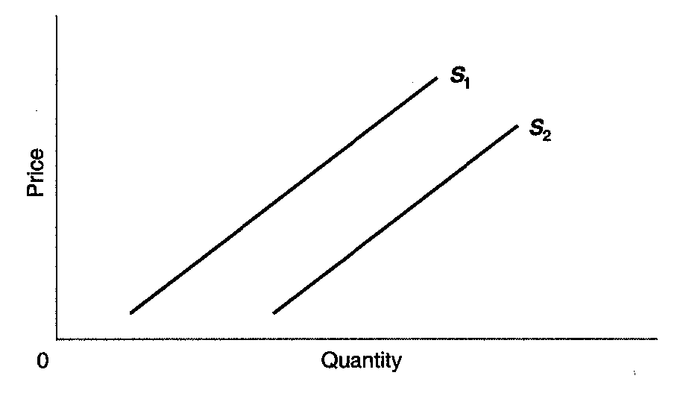
- If the supply curve moves from S₁ to S₂ on the graph below, there has been

  - an increase in supply
  - a decrease in supply
  - an increase in quantity supplied
  - a decrease in quantity supplied

- If the quantity supplied of a product is greater than the quantity demanded for a product, then
  - there is a shortage of the product
  - there is a surplus of the product
  - the product is a normal good
  - the product is an inferior good

- If the price of a product is below the equilibrium price, the result will be
  - a surplus of the good
  - a shortage of the good
  - a decrease in the supply of the good
  - an increase in the demand for the good
Answer Questions 14, 15, and 16 on the basis of the data in the following table. Consider the following supply and demand schedules for bushels of corn.

Price | Quantity  demanded | Quantity  supplied
$20 | 395 | 200
22 | 375 | 250
24 | 350 | 290
26 | 320 | 320
28 | 280 | 345
30 | 235 | 365

- The equilibrium price in this market is
  - $22
  - $24
  - $26
  - $28

- An increase in the cost of labor lowers the quantity supplied by 65 bushels at each price. The new equilibrium price would be
  - $22
  - $24
  - $26
  - $28

- If the quantity demanded at each price increases by 130 bushels, then the new equilibrium quantity will be
  - 290
  - 320
  - 345
  - 365

- A decrease in supply and a decrease in demand will
  - increase price and decrease the quantity exchanged
  - decrease price and increase the quantity exchanged
  - increase price and affect the quantity exchanged in an indeterminate way
  - affect price in an indeterminate way and decrease the quantity exchanged

- An increase in demand and a decrease in supply will
  - increase price and increase the quantity exchanged
  - decrease price and decrease the quantity exchanged
  - increase price and the effect upon quantity exchanged will be indeterminate
  - decrease price and the effect upon quantity exchanged will be indeterminate
- A cold spell in Florida devastates the orange crop. As a result, California oranges command a higher price. Which of the following statements best explains the situation?
  - The supply of Florida oranges decreases, causing the supply of California oranges to increase and their price to increase.
  - The supply of Florida oranges decreases, causing their price to increase and the demand for California oranges to increase.
  - The supply of Florida oranges decreases, causing the supply of California oranges to decrease and their price to increase.
  - The demand for Florida oranges decreases, causing a greater demand for California oranges and an increase in their price.

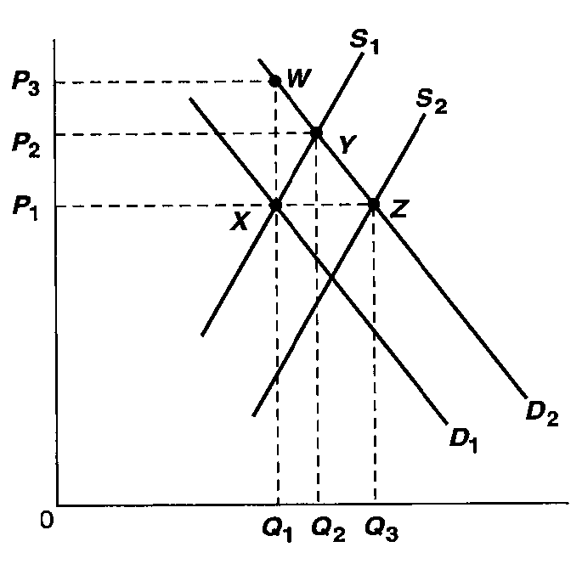
Answer Questions 20, 21, 22, and 23 based on the graph below showing the market supply and demand for a product.

- Assume that the market is initially in equilibrium where D₁ and S₁ intersect. If there is an increase in the number of buyers, then the new equilibrium would most likely be at point
  - W
  - X
  - Y
  - Z

- Assume that the equilibrium price and quantity in the market are P₂ and Q₂. Which factor would cause the equilibrium price and quantity to shift to P₁ and Q₃?
  - an increase in product price
  - an increase in demand
  - an increase in supply
  - a decrease in quantity
- What would cause a shift in the equilibrium price and quantity from point Z to point X?
  - a decrease in production costs and more favorable consumer tastes for the product
  - an increase in the number of suppliers and an increase in consumer incomes
  - an increase in production costs and decrease in consumer incomes
  - an improvement in production technology and decrease in the price of a substitute good

- Assume that the market is initially in equilibrium where D₁ and S₁ intersect. If consumer incomes increased and the technology for making the product improved, then the new equilibrium would most likely be at
  - P₁ and Q₁
  - P₂ and Q₂
  - P₁ and Q₃
  - P₃ and Q₁

Questions 24 and 25 relate to the following table that shows a hypothetical supply and demand schedule for a product.

Quantity demanded  (pounds) | Price  (per pound) | Quantity supplied  pounds
200 | $4.40 | 800
250 | 4.20 | 700
300 | 4.00 | 600
350 | 3.80 | 500
400 | 3.60 | 400
450 | 3.40 | 300
500 | 3.20 | 200

- A shortage of 150 pounds of the product will occur if a government-set price is established at
  - $3.20
  - $3.40
  - $3.80
  - $4.00

- If a price floor set by the government is established at $4.20, there will be a
  - surplus of 300 pounds
  - shortage of 300 pounds
  - surplus of 450 pounds
  - shortage of 450 pounds

- PROBLEMS

- Refer to O’Rourke’s demand schedule on top of the next page. Assume that O’Rourke has, when his income is $100 per week, the demand schedule for good A shown in columns 1 and 2 of the following table and the demand schedule for good B shown in columns 4 and 5. Assume that the prices of A and B are $.80 and $5, respectively.

Demand for A (per week) |  |  |  | Demand for B (per week)
(1)  Price | (2)  Quantity demanded | (3)  Quantity demanded |  | (4)  Price | (5)  Quantity demanded | (6)  Quantity demanded
$.90 | 10 | 0 |  | $5.00 | 4 | 7
.85 | 20 | 10 |  | 4.50 | 5 | 8
.80 | 30 | 20 |  | 4.00 | 6 | 9
.75 | 40 | 30 |  | 3.50 | 7 | 10
.70 | 50 | 40 |  | 3.00 | 8 | 11
.65 | 60 | 50 |  | 2.50 | 9 | 12
.60 | 70 | 60 |  | 2.00 | 10 | 13

  - How much A will O’Rourke buy? ________
How much B? ________

  - Suppose that as a consequence of a $10 increase in O’Rourke’s weekly income, the quantities demanded of A become those shown in column 3 and the quantities demanded of B become those shown in column 6.
    - How much A will he now buy? ________
How much B? ________
    - Good A is (normal, inferior) ____________.
    - Good B is ____________.

- Using the demand schedule below plot the demand curve on the graph at the top of the next column. Label the axes and indicate for each axis the units being used to measure price and quantity.

Price | Quantity demanded  1000 bushels of soybeans
$7.20 | 10
7.00 | 15
6.80 | 20
6.60 | 25
6.40 | 30
6.20 | 35

  - Plot the following supply schedule on the same graph.

Price | Quantity supplied  1000 bushels of soybeans
$7.20 | 40
7.00 | 35
6.80 | 30
6.60 | 25
6.40 | 20
6.20 | 15

  - The equilibrium price of soybeans will be $______.

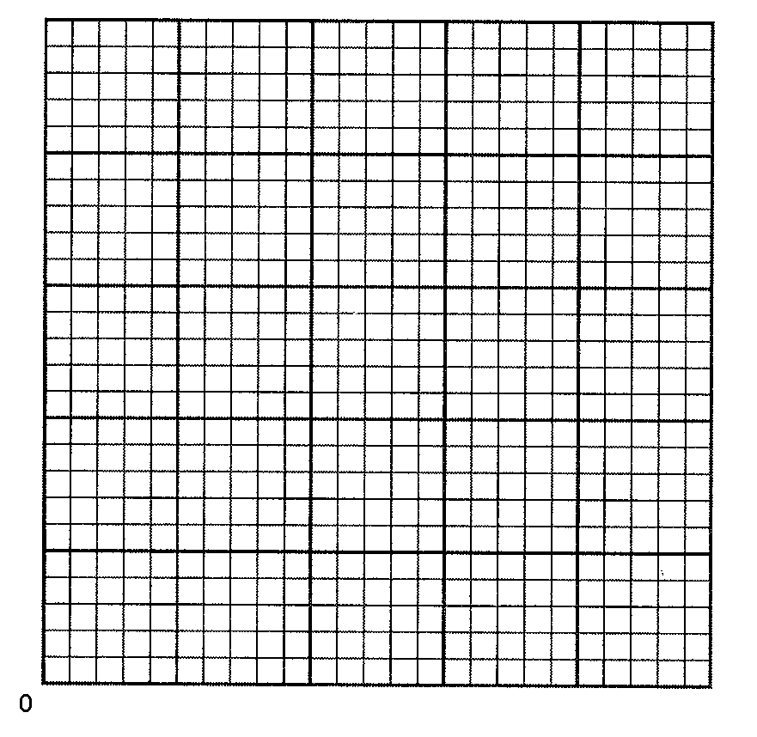
  - How many thousand bushels of soybeans will be exchanged at this price? ___________
  - Indicate clearly on the graph the equilibrium price and quantity by drawing lines from the intersection of the supply and demand curves to the price and quantity axes.

  - If the Federal government supported a price of $7.00 per bushel there would be a (shortage, surplus) ____________ of _______ bushels of soybeans.

- The market demand for good X is shown in columns 1 and 2 of the first table on the next page. Assume the price of X to be $2 and constant.
  - If as the price of good Y rises from $1.25 to $1.35, the quantities demanded of good X become those shown in column 3, it can be concluded that X and Y are (substitute, complementary) _____________ goods.
(1)  Price | (2)  Quantity demanded | (3)  Quantity demanded | (4)  Quantity demanded
$2.40 | 1600 | 1500 | 1700
2.30 | 1650 | 1550 | 1750
2.20 | 1750 | 1650 | 1850
2.10 | 1900 | 1800 | 2000
2.00 | 2100 | 2000 | 2200
1.90 | 2350 | 2250 | 2450
1.80 | 2650 | 2550 | 2750

  - If as the price of good Y rises from $1.25 to $1.35, the quantities of good X become those shown in column 4, it can be concluded that X and Y are _____________ goods.

- In a local market for hamburger on a given date, each of 300 identical sellers of hamburger has the following supply schedule.

(1)  Price | (2)  Quantity supplied—one seller, lbs | (3)  Quantity supplied—all sellers, lbs
$3.05 | 150 | _____
3.00 | 110 | _____
2.95 | 75 | _____
2.90 | 45 | _____
2.85 | 20 | _____
2.80 | 0 | _____

  - In column 3 construct the market supply schedule for hamburger.
  - Following is the market demand schedule for hamburger on the same date and in the same local market as that given above.

Price | Quantity demanded, lbs
$3.05 | 28,000
3.00 | 31,000
2.95 | 36,000
2.90 | 42,000
2.85 | 49,000
2.80 | 57,000

If the Federal government sets a price on hamburger of $2.90 a pound, the result would be a (shortage, surplus) ___________ of _______ pounds of hamburger in this market.
- Each of the following events would tend to increase or decrease either the demand for or the supply of computer games and, as a result, will increase or decrease the price of these games. In the first blank indicate the effect on demand or supply (increase, decrease); in the second blank, indicate the effect on price (increase, decrease). Assume that the market for computer games is competitive.

  - It becomes known that an electronics store is going to have a sale on these games one month from now.
_______________; _______________
  - The workers in the industry receive a $10 an hour wage increase.
_______________; _______________
  - Several research studies are reported showing that the youth who play computer games also improve their grades in school.
_______________; _______________
  - Because of the use of mass production techniques, the amount of labor necessary to produce a game decreases.
_______________; _______________
  - The price of computers decreases.
_______________; _______________
  - The Federal government imposes a $5 tax per game on the manufacturers of computer games. _______________; _______________

- SHORT ANSWER AND ESSAY QUESTIONS

- Define demand and the law of demand.
- In past decades, the price of coffee in the United States rose significantly as a result of bad weather in coffee-producing regions. Use the income effect and the substitution effect concepts to explain why the quantity of coffee demanded in the United States significantly decreased.
- What is the difference between individual demand and market demand? What is the relationship between these two types of demand?
- What are the factors that cause a change in demand? Use supply and demand graphs to illustrate what happens to price and quantity when demand increases.
- How are inferior and normal (or superior) goods defined? What is the relationship between these goods and changes in income?
- Why does the effect of a change in the price of related goods depend on whether a good is a substitute or complement? What are substitutes and complements?
- Explain the difference between an increase in demand and an increase in the quantity demanded.
- Compare and contrast the supply schedule with the demand schedule.
- Supply does not remain constant for long because the factors that determine supply change. What are these factors? How do changes in them affect supply?
- Explain the meaning of equilibrium price and quantity. Use the terms shortage and surplus in your answer.
- What is the meaning of the “rationing function of prices”?
- Explain the difference between an increase in supply and an increase in the quantity supplied.
- A newspaper reports that “blue jeans have become even more popular and are now the standard clothing that people wear for both play and work.” How will this change affect the demand for blue jeans? What will happen to the price and quantity of blue jeans sold in the market? Explain and use a supply and demand graph to illustrate your answer.
- Describe and illustrate with a supply and demand graph the effect of an increase in supply on price and quantity. Do the same for a decrease in supply.
- The U.S. Congress passes a law that raises the excise tax on gasoline by $1 per gallon. What effect will this change have on the demand and supply of gasoline? What will happen to gasoline prices and quantity? Explain and use a supply and demand graph to illustrate your answer.
- What is the relationship between the price of a product and a shortage of the product? What is the relationship between the price of a product and a surplus of the product?
- Given the demand for and the supply of a commodity, what price will be the equilibrium price of this commodity? Explain why this price will tend to prevail in the market and why higher (lower) prices, if they do exist temporarily, will tend to fall (rise).
- Suppose an industry sells 2000 units of a product at $10 per unit one year, 3000 units at $12 the next year, and 4000 units at $14 the third year. Is this evidence that the law of demand is violated? Explain.
- What are the consequences of a price ceiling for a product if it is set below the equilibrium price? Illustrate your answer with a graph.
- What are the economic problems with price floors? How have they been used by government?
ANSWERS
Chapter 3 Demand, Supply,
and Market Equilibrium

FILL-IN QUESTIONS
- demanders, suppliers
- an inverse, a direct
- vertical, horizontal
- adding, prices
- substitutes, complements
- a. the tastes or preferences of consumers; b. the number of consumers in the market; c. the money income of consumers; d. the prices of related goods; e. changes in expected prices(any order for a–e)
- smaller, less
- demand for, quantity demanded of
- rises, falls
- adding, prices
- a. the technology of production; b. resource prices; c. taxes and subsidies; d. prices of other goods; e. price expectations; f. the number of sellers in the market (any order for a–f)
- larger, less
- supply, quantity supplied
- below, shortage, rise, above, surplus, fall
- equal to, is not
- rationing, clearing
- voluntary, money, tickets
- a. +, +; b. –, +; c –, –; d. +, –; e. ?, +; f. +, ?; g. ?, –; h. –, ?
- maximum, minimum
- shortage, surplus

TRUE–FALSE QUESTIONS
1. T, p. 51–52 | 10. T, pp. 55–56 | 19. F, p. 61
2. F, p. 52 | 11. F, pp. 55–56 | 20. T, pp. 61–62
3. F, pp. 52–53 | 12. F, p. 56 | 21. T, pp. 62–63
4. F, pp. 53–54 | 13. F, p. 57 | 22. T, p. 64
5. F, p. 53 | 14. F, pp. 57–58 | 23. F, p. 65
6. F, pp. 52–53 | 15. T, pp. 59–60 | 24. T, pp. 64–65
7. T, p. 55 | 16. F, p. 60 | 25. F, pp. 66–67
8. T, p. 55 | 17. F, p. 60
9. T, p. 55 | 18. T, p. 60

MULTIPLE-CHOICE QUESTIONS
1. b, p. 52 | 10. a, p. 60 | 19. b, pp. 64–66
2. d, pp. 52–53 | 11. a, pp. 59–60 | 20. c, pp. 55, 64–66
3. b, pp. 53–54 | 12. b, pp. 61–62 | 21. c, pp. 59, 64–66
4. d, p. 55  5. b, p. 55 | 13. b, pp. 61–62  14. c, pp. 61–62 | 22. c, pp. 55, 59–60,  64–66
6. a, p. 55 | 15. d, pp. 61–62 | 23. c, pp. 55, 60, 64–66
7. b, pp. 55–56 | 16. d, pp. 61–62 | 24. b, pp. 66–68
8. a, pp. 55–56 | 17. d, pp. 64–66 | 25. c, pp. 68–69
9. c, p. 58 | 18. c, pp. 64–66

PROBLEMS

- a. 30, 4; b. (1) 20, 7; (2) inferior; (3) normal (superior)
- a. graph; b. 6.60; c. 25,000; d. graph; e. surplus, 20,000
- a. complementary; b. substitute
- a. 45,000; 33,000; 22,500; 13,500; 6,000; 0; b. shortage, 28,500
- a. decrease demand, decrease price; b. decrease supply, increase price; c. increase demand, increase price; d. increase supply, decrease price; e. increase demand, increase price; f. decrease supply, increase price

SHORT ANSWER AND ESSAY QUESTIONS

1. pp. 52–53 | 8. pp. 52–54; 57–58 | 15. pp. 60, 64
2. pp. 55–56 | 9. pp. 59–60 | 16. pp. 61–62
3. pp. 52–54 | 10. pp. 61–62 | 17. pp. 61–62
4. pp. 55–56 | 11. pp. 62–63 | 18. pp. 61–62
5. pp. 55–56 | 12. p. 61 | 19. pp. 66–68
6. pp. 55–56 | 13. p. 64 | 20. pp. 68–69
7. p. 57 | 14. p. 64

